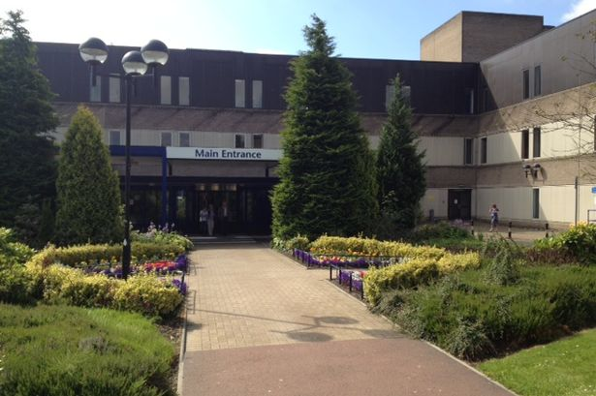

St John’s Hospital Water Systems

Water Safety Plan/Written Scheme

Controlling the risks of exposure to Legionella and other harmful bacteria in Water Systems

2021 Rev 1

Reviewed by: G. Curley (Facilities Director/Designated Person Water)
D. Kelly (NHS Lothian Authorised Engineer)
Tommy Logan (Head of Estates/Responsible Person)

An electronic copy of this document is held on the St John’s Hospital Shared Drive at folder path:
K Drive Estates Shared>Water Quality>Written Schemes

Table of Contents
1.0 GENERAL OVERVIEW 3
1.1 Introduction 3
1.2 Executive Summary............................................................................................................................ 4
1.3 Overview of Site Accommodation and Premises 5
2.0 RECORDING 6
2.1 Water Safety Plan and Written Scheme Inspection Records 6
2.2 Location of Records and Correspondence 7
2.3 Non-Compliance Issues and Fault Detail Log 8
2.4 Archived Information Record Sheet 9
2.5 Equipment Calibration Records 10
3.0 MANAGEMENT ARRANGEMENTS 11
3.1 Roles & Responsibilities 11
3.2 Estates Staffing 12
3.3 Required Maintenance Tasks 13
3.4 Training Records 16
3.5 Training Requirements 17
3.6 Water Systems Risk Assessment 18
3.7 Plant Description and Schematics – See Appendix 2 18
3.8 Water Systems Audits/Review Procedures 19
3.9 Water Safety Plan – Written Scheme Audit Procedure 20
3.10 Management Review 20 3.11WaterSystemSCARTReport.............................................................................................................21
3.12Contractor Management& Audit Report...........................................................................................21
3.13Incident Plan......................................................................................................................................21
4.0 Maintenance Procedures............................................................................................................................22
4.1 Maintenance Task Schedules Error! Bookmark not defined.
4.1.1 SFG 20 22
5.0 Supporting Information Relating To The Control Scheme....................................................................25
5.1 Failure of Control Measure.................................................................................................................26
5.2 Positive Legionella Test Results..........................................................................................................24
5.3 Emergency Repairs..........................................................................................................................................................26
5.4 Disinfection of Water System and Component.....................................................................................................29
5.5 Pseudomonas SOP...............................................................................................................................30
5.6 Specific Augmented Care Areas.........................................................................................................29
Appendix 1 - Site Plan 34
Appendix 2 – Schematic Drawing St John’s Hospital.............................................................................35
Appendix 3 – Portable Water Sample Out of Spec Results Escalation Procedures.............................39
Appendix 4 – Risk Assessment Review Guidance....................................................................................38

1.0 GENERAL OVERVIEW
This Water Safety Plan (WSP) shall cover the Johns Hospital including:-

Main Hospital Building
Laundry
Boiler house
Estates
MPU –OPD 1
Residence Block1/1
Residence Block ½
Residence Block1/3
Residence Block 2/4
Residence Block 2/5
Residence Block 3/6
Residence Block 3/7
Residence Block 3/8
Residence Block 4/9
Residence Block 4/10
Compass (retail Unit)

The Water Safety Plan aims to demonstrate the method, controls, governance and structures NHS Lothian has implemented to ensure water systems are safe for patients, staff, and visitors.
Note 1: No work will be carried out on the water system without the knowledge and written consent of the Authorised Person (Water).
Note 2: This Written Scheme document is to be read in conjunction with the Operational Procedures for the Written Schemes document and should also be read in conjunction with the Control of Water Records document. For any alterations to the Water System this Written Scheme Document is to be read in conjunction with the Guidance for alterations to water systems document.

1.1 Introduction
This document contains five sections which have been derived from the Risk Assessment to aid the design, installation, maintenance and operational mode of all domestic and process water systems within the premises with respect to the likelihood of the proliferation of waterborne micro-organisms.
Section 1 - Executive Summary of the recommended control measures contains a corrective actions and overview of the St John’s Hospital Campus.
Section 2 - Record of the logbook inspection, details on the location of records, defects, non-compliance issues, correspondence and archived information.
Section 3 Demonstrates the in place Duty Structure associated with Water Safety across the campus and defines the Roles Responsibilities.
Secondary, details of the risk assessment values associated with representative outlets are demonstrated.
A generic risk assessment for any positive Legionella test results within designated Low Risk locations and a description of the installed plant and equipment with associated schematic layout plans for each of the installed water systems within the site is also contained within this section.
Section 4 - details the safe operation of the system and all appropriate Maintenance Procedures (Control Measures) which were derived from the Risk Assessment and recommendations within NHS Lothian Water Systems Safety Policy.
Section 5 - supporting information relating to the Control Scheme:-
System Alterations
Adhoc Maintenance operations – sterilizer operations
Specific Augmented Care Areas

1.2 Executive Summary
The purpose of this Water Safety Plan - Written Scheme document is to demonstrate the current operational systems for water safety within the St John’s Campus. The Johns campus is the acute hospital for West Lothian region and currently delivers services to patients per annum through the delivery of services by NHS staff and contractors.
The campus has been fully risk assessed by Westfield Caledonian in April 2020, with the annual review dues on April 2021 under the governance of the Board Water Safety Group.
Hydrotherapy pools, birthing pools provide conditions that potentially favour the growth of Legionella. While there have been no reported cases of Legionella infections associated with hydrotherapy pool or birthing pool. Careful maintenance and chemical treatment is essential to maintain water quality, and a log must be kept of water treatment and filter cleaning, and the result of test for pH, free residual halogen and other treatment parameters.
There is daily maintenance check carried out on hydrotherapy pool by the maintenance assistants who would pick up an issue regarding filter changes and pH levels.
The site subject to formal Risk Assessment every two years or when there has been significant change to the site. There will also be annual Audit reviews completed to ensure the progress of the findings of the assessments is progress to reduce any known risks.
Guidance on the Risk Assessment review procedure is given in Appendix 4.

All documentation and log sheets used to record maintenance activities follow the format contained within guidance document SHTM 04-01 Part G: Operational Procedures and Exemplar Written Scheme.( These forms can be found on the shared Q drive> Estates management> Quality Water Reports)

1.3 Overview of Site Accommodation and Premises
St John’s Hospital is a modern teaching hospital that provides a comprehensive and expanding range of services for the people of Lothian and beyond.
The hospital, based at Howden in Livingston, has a 24-hour Accident and Emergency department and a range of specialist services including burns treatment and plastic surgery.
There is a full paediatric service at the hospital, including an acute receiving unit, special baby unit, paediatric ward and a comprehensive range of outpatient services.
St John’s is home to the Short Stay Elective Surgical Centre, which opened in January 2011, and treats around 3,000 patients a year from across Lothian for day surgery.
The hospital also hosts Lothian’s specialist head and neck unit and the Hooper Hand Unit, and has a reputation for excellence in maternity services, with around 3,000 babies born at the hospital every year. During 2014, the labour suite and special care baby unit were refurbished and upgraded.​
Top of Form

Services

St John’s offers patients a wide range of services including:
- Accident and Emergency
- Burns
- Cardiology
- Dermatology
- Ear, Nose and Throat
- Endocrinology
- Gastroenterology
- General medicine
- General surgery
- Gynaecology
- Haematology
- Laboratories
- Maxillofacial surgery
- Mental Health - managed by West Lothian CHCP
- Nephrology
- Neurology
- Obstetrics
- Opthalmology
- Orthopaedics
- Paediatrics
- Plastic surgery
- Renal dialysis
- Respiratory medicine
- Rheumatology
- Surgical paediatrics
Bottom of Form

See Site Map-Schematic Drawing in Appendix 1

2.0 RECORDING

2.1 Water Safety Plan and Written Scheme Inspection Records
Anyone inspecting this water safety plan (either as part of the Management Control System or otherwise) is invited to make an entry in this inspection record. Under no circumstances may this Water Safety Plan or any part of it be removed from site.

Date/Time | Comments | Signature | Position
Feb 2021 | Written scheme has been reviewed and re-formatted into this current form (Revision 1) by Heather McLeary as part of the water systems review. |  | Assurance Manager Operational Estates
April 2021 | The water safety plan/written scheme has now been approved by the relevant management team |  | Jim Crombie  George Curley  Tommy Logan
March/April 2021 | New Risk Assessment from Westfield Caledonian | Heather Mcleary | Assurance Manager
Additional entries should be completed on a separate sheet and inserted in Section 2.1 with this sheet.

2.2 Location of Records and Correspondence
Details of any correspondence, including Risk Assessments/Reviews and Ongoing Monitoring Reports, relating to water services should be entered on the sheet below, recording where held and by whom.

Date | Procedure or Record ref | Description | Held by/location
July 2016 | Water Safety Quality Report | Westfield Caledonian Quality Audit Report | Hard Copy on K Drive
July 2017 | Water Safety Risk Assessment | Westfield Caledonian Water Safety Risk Assessment | Hard Copy on K Drive
February 2018 | Water Safety Risk Assessment | Westfield Caledonian Water Safety Risk Assessment | Hard Copy on K Drive
March 2020 | Water Safety Risk Assessment | Westfield Caledonian Water Safety Risk Assessment | Hard Copy on K Drive
October 2020 | Water Safety Risk Assessment | Westfield Caledonian Water Safety Risk Assessment | Hard Copy on K Drive
April 2021 | Water Safety Risk Assessment | Westfield Caledonian Water Safety Risk Assessment | Hard Copy on K Drive

2.3 Non-Compliance Issues and Fault Detail Log
Record Form 004
All non-compliance and fault details in relation to the individual systems in each building must be recorded on Record Form 004 and brought to the attention of the Water Systems Lead AP as soon as possible. This process ensures that all non-compliance issues are documented, managed effectively and tracked through to completion and close –out of the issue. Copies of the all Record Form 004 are to be stored locally within the Estates Management office.

2.4 Archived Information Record Sheet
All records associated with the management or maintenance procedures within this Water Safety Plan and Written Scheme should be kept for a period of five years after they are no longer current. Records should be kept locally within the main Estates Office. The details of any archived information held separately in secure storage should be recorded in the table below.

Date | Procedure or Record  Reference | Description | Held By/Location
Additional entries should be completed on a separate sheet and inserted in Section 2.4

2.5 Equipment Calibration Records
All equipment used for the measurement of temperatures should be calibrated at least annually to ensure the accuracy and consistency of the recording procedures.

Calibration certificates for handheld thermometers are held in hard copy within the Estates management Q Drive, hard copy held within Estates Manager main estates office. Electronic copies are also held on the Q Drive>Calibration.

See Attached - asset and calibration equipment list:

3.0 MANAGEMENT ARRANGEMENTS

3.1 Roles & Responsibilities
Designation | Position | Name  Tel Number
The Duty Holder | Deputy Chief Executive | Jim Crombie
Designated Person (Water) | Director of Facilities/General Manager (Estates) | George Curley
Authorising Engineer (Water) | Legionella Control International Ltd | Dennis Kelly  07801 640127
Responsible Person (Water) | Head of Estates | Tommy Logan
Regional Responsible Person | Estates Manager | Ian McKechnie
Authorised Persons | Estates Sector Manager  Estates Sector Manager  Estates Sector Manager | Ian Strachan  Michael Mastaglio  Rae Jarvis
Competent Persons | Plumbers/Engineers | See training records in Estates Office
Others Involved
Microbiologist | Lead Microbiologist | Karen MacSween
Infection Control | Lead Infection Control | Lindsay Guthrie
See Thumbnail for Management Responsibilities
The Water Safety Group meets quarterly the following below attend. This meeting also feeds into the Senior Management Water safety Group which also meets on quarterly basis.

Site Management Representative
Facilities Representative
Associate medical Director
Health & Safety Advisor
IPCN Representative
Domestic Services Representative
Clinical Nurse Manger
RCN Steward/Mental Health Partnership Rep

3.2 Estates Staffing
Management for St John’s Hospital

Jim Crombie
Deputy Chief Executive

George Curley
Director of Facilities

Estates Competent Persons (Water Systems)
See Training Records in Section 3.4 for trained staff list
Michael Mastaglio
Estates Sector Manager (AP Water Systems)

Rae Jarvis
Estates Officer (Water Systems AP)

Ian Strachan
Estates Sector Manager
(AP Water Systems)

Ian McKechnie
Area Hard FM Manager
Regional Responsible Person
Tommy Logan - Head of Estates Hard FM (Pan Lothian)

3.3 Required Maintenance Tasks
The maintenance and management of the water systems throughout St John’s Hospital is undertaken by a combination of NHS Staff at the frequencies identified in the following tables.

St John’s Hospital Management staffs manage and oversee the following tasks:

Planned Maintenance | Priority
51-05 - Showers - Thermostatic Mixing Valve (TMV) - Type 2 - 3Month  51-05 - Showers - Thermostatic Mixing Valve (TMV) - Type 2 - 6Month  51-05 - Showers - Thermostatic Mixing Valve (TMV) - Type 2 - 12Month  51-05 - Showers - Thermostatic Mixing Valve (TMV) - Type 2 - 3Year  51-05 - Showers - Thermostatic Mixing Valve (TMV) - Type 2 - 6Year  SHTM 04-04 - Thermostatic Mixing Valves (TMV) - 6Week  SHTM 04-04 - Thermostatic Mixing Valves (TMV) - 12Month  29-08 - Heating Calorifiers - MTHW HTHW or Steam - 12Month  29-08 - Heating Calorifiers - MTHW HTHW or Steam - 3Month  56-02 - Cold Water Storage Tanks and Cisterns - 6Month  56-02 - Cold Water Storage Tanks and Cisterns - 12Month  SHTM 04-01 - Hot and Cold Water Temperature Monitoring - 1Month  SHTM 04-01 - Hot and Cold Water Temperature Monitoring - 3Month  SHTM 04-01 - Hot and Cold Water Temperature Monitoring - 12Month  SHTM 04-01 - Hot and Cold Water Temperature Monitoring - 6Month  32-06 - Hot Water Calorifiers - Heated by MTHW HTHW or Steam - 1Month  32-06 - Hot Water Calorifiers - Heated by MTHW HTHW or Steam - 12Month  32-06 - Hot Water Calorifiers - Heated by MTHW HTHW or Steam - 24Month  45-10 - Sump Pumps and Extended Shaft Sump Pumps - 3Month  45-10 - Sump Pumps and Extended Shaft Sump Pumps - 6Month  45-10 - Sump Pumps and Extended Shaft Sump Pumps - 12Month  45-12 - Water Booster Pumps - 3Month  45-12 - Water Booster Pumps - 12Month  65-10 - Chemical Dosing - 3Month  65-10 - Chemical Dosing - 6Month  65-10 - Chemical Dosing - 12Month  65-10 - Chemical Dosing - 1Month  65-18 - Chlorine Analyser/Controller System - 1Day  65-18 - Chlorine Analyser/Controller System - 1Week  65-18 - Chlorine Analyser/Controller System - 4Week  65-18 - Chlorine Analyser/Controller System - 6Month  66-02 - Hydrotherapy Pools - 1Day  66-02 - Hydrotherapy Pools - 1Week  66-02 - Hydrotherapy Pools - 1Month  66-02 - Hydrotherapy Pools - 3Month  66-02 - Hydrotherapy Pools - 6Month  66-02 - Hydrotherapy Pools - 12Month  40-16 - Water Buffer/Surge Tanks - 1Month  40-16 - Water Buffer/Surge Tanks - 6Month  40-16 - Water Buffer/Surge Tanks - 12Month  56-10 - Hotwell/Boiler Feed Tank - 3Month  56-10 - Hotwell/Boiler Feed Tank - 12Month | PPM - 3M  PPM - 6M  PPM - 12M  PPM - 3Y  PPM - 6Y  PPM - 6W  PPM - 12M  PPM - 12M  PPM - 3M  PPM - 6M  PPM - 12M  PPM - 1M  PPM - 3M  PPM - 12M  PPM - 6M  PPM - 1M  PPM - 12M  PPM - 24M  PPM - 3M  PPM - 6M  PPM - 12M  PPM - 3M  PPM - 12M  PPM - 3M  PPM - 6M  PPM - 12M  PPM - 1M  PPM - 1D  PPM - 1W  PPM - 4W  PPM - 6M  PPM - 1D  PPM - 1W  PPM - 1M  PPM - 3M  PPM - 6M  PPM - 12M  PPM - 1M  PPM - 6M  PPM - 12M  PPM - 3M  PPM - 12M

See Thumbnail for St John’s Campus Water Asset

3.3 Required Maintenance Tasks (cont)

In addition to the tasks undertaken by NHS directly, there are also tasks undertaken by Contractors on a selection of buildings within the campus.

Appointed Contractors presently undertake the following tasks:

Operation(s) | Contractor | Frequency
Risk Assessments | Westfield Caledonian | Every 2 year unless any changes to water system
Review and Audit Report | Westfield Caledonian | Annually
Disinfection | RL Building services LTD | When Required
Heat plate inspection | Spirax Sarco | Annually
Sampling | Westfield Caledonian | When Required
TVC | Westfield Caledonian | On a 6 monthly sampling routine
Legionella Sampling | Westfield Caledonian | On a 6 monthly sampling routine
Pseudomonas Sampling | Westfield Caledonian | On a 6 monthly sampling routine

3.4 Training Records
The following NHS personnel are certified to have the required ability, experience, instruction, information and training to carry out the work associated with Legionella precautions at St John’s Hospital.
Name | Position | Nature of Training (Qualification, Training Courses Attended) | Date
Dennis Kelly | Authorising Engineer  AE | Appointment as Authorising Engineer – Water Safety (SHTM) Best Practise Guidance (SHTM) 04-01 Water safety (HTM) 04-01 Specific Contract under Framework Agreement NP813-18  Responsible Person Course | 4th March 2019
Ian Strachan | Estates Manager  AP | WHH01 – Legionella Management for Water Systems SHTM-04 01  WH003 - Legionella Control Within Hot and Cold Water Systems | Dec – 2020
Michael Mastaglio | Estates Manager  AP | WHH01 – Legionella Management for Water Systems SHTM-04 01  WH003 - Legionella Control Within Hot and Cold Water Systems | Dec -2020
Rae Jarvis | Estates Officer  AP | WHH01 – Legionella Management for Water Systems SHTM-04 01  WH003 - Legionella Control Within Hot and Cold Water Systems | May-2020
Nathan McGuigan | Plumber | WS13 Thermostatic Mixing Valves  Legionella Awareness | Feb-2020
Colin Darling | Plumber | WS13 Thermostatic Mixing Valves  Legionella Awareness | Feb-2020
Tom Cunningham | Plumber | Maintaining Safe Water System CP Refresher | Feb-2019
John Hamilton | Fitter | Legionella & Microbiologic Awareness | Feb - 2020
Graham Lawson | Fitter | Legionella & Microbiologic Awareness | Feb-2020
John Kean | Fitter | Legionella & Microbiologic Awareness | Feb-2020
Billy Spiers | Maintenance Assistant | Legionella & Microbiologic Awareness | Feb-2020
Derek Cunningham | Maintenance Assistant | Legionella & Microbiologic Awareness | Feb-2020

Copies of all relevant training records and appointment letters are held electronically on the Shared K Drive within the folder path Assurance & Compliance>Water Safety> Training and Appointments”.
The results achieved by each member of staff during their competency training are held on the central database managed by the Water Systems.

3.5 Training Requirements
A programme of training and procedures to assist in assessing and ensuring the competence of ALL persons responsible for the operation, maintenance, repair and alteration to the water distribution system and associated plant and equipment requires being progressed, developed and implemented.

Training>SJH

Item | Training Requirement | Applicable to | Target Date  for  Completion | Date  Completed
1 | Legionella Awareness | All plumbers | End of 2021
2 | Maintaining safe water system Refresher | All plumbers | End of 2021
3 | Water AP – every 3 years | Water System | Complete | Complete
4
5
6
7
8
9
10

NOTE:- This table should be updated on a regular basis as part of the review process described in Section 3.10.

3.6 Water Systems Risk Assessment
Risk Assessments have been conducted by Westfield Caledonian.
Electronic copies of the assessment will be stored with Agility, with paper copies held on site within each logbook.
Risk Assessment Review-Escalations
The Water Risk Assessment upon completion is issued to the site Area Manager (Ian McKechnie – Water Approved Person) for review. Remedial action plan agreed with Westfield Caledonian and the programme of work are either delivered through a defined reinstatement programme or individual tasks raised through NHSL maintenance planning system Agility and allocated to the appropriate trade or contractor for delivery. The method of delivery shall be determined on the value of risk and volume of remedial actions.
Any risk or remedial actions not progressed shall be located within the pan Lothian water risk register, which is located within K Drive > Pan Lothian>Water Quality Reports>Water Safety Risk Register.
Risk Assessment Process for Removal of Identified Items
Points are actioned that have been identified in the Risk Assessment, all drawings are updated to reflect the changes and the Risk Assessment action point is closed.
Risk Assessment Review Schedule
A review of the Risk Assessments MUST be carried out after or during the following:
A change to the water system or its use -:
Control measures becoming ineffective
Increased micro-bacterial levels found in the water system or a case of legionnaire’s disease/legionellosis associated with the water system.

3.7 Plant Description and Schematics – See Appendix 2
The logbooks/risk assessments are stored in the main Estates Office at St John’s Hospital.

3.8 Water Systems Audits/Review Procedures
A duly appointed Authorising Engineer (Water) will audit the entire Water Safety procedures within NHS Board annually.
The appointed Authorising Engineer (Dennis Kelly) for Water Safety will produce an annual report for management review.
AE Audit
The Authorised Person (Water) and Assurance Manager must regularly gather and maintain all the relevant information and records, including relevant Water Safety Risk Assessments.
Working with the Authorising Engineer (Water), the relevant Authorised Person (Water) will review and analyse all records for compliance with Legionella and other water safety parameters.
The relevant Authorised Person (Water) will detail on these records any deviations from the Legionella and other water safety parameters giving a brief description as to the reason for this deviation.
The Audit Programme will consist of the following elements, for example:
Risk Assessments;
All documentation associated with this Water Safety Plan – Written Scheme
Training review and records;
Schematic drawings;
Water Safety Log Books/Maintenance records;
A report will be produced summarising the audit for submission to the Sector Water Safety Group.
The Authorised Person (Water) will file locally, all relevant information and maintain hard copy records in the Water Safety Log Books stored within the main Estates Office. All actions identified should be tracked to ensure completion and closure.
Summary of Internal/External Audit Procedures

Frequency | Task | By Whom
Annually | Carry out Authorising Engineers Audit and produce report for submission to Sector Water Safety Group | Lead AP, AE,
Annually | Carry out annual review of water safety plan/written scheme and produce report for submission to Sector Water Safety Group | AP, Assurance Mgr
Annually | Carry out regular audit of SCART topic and update database | AP

3.9 Water Safety Plan - Written Scheme Audit Procedure
The Water Safety Plan - Written Scheme will be audited at agreed intervals but should be at least annually.
An audit schedule will be prepared to ensure the entire procedure is audited. This should be done in conjunction with the AP (Water Systems), Assurance Manager, and Responsible Person (Water Systems). A report should be produced and submitted to the Sector Water Safety Group.

3.10 Management Review
The Responsible Person (Water) will hold regular review meetings to confirm current compliance with Water Safety System requirements, identification of any deficiencies and actions required to resolve staff training needs.

The management review will be based on following:
Results of internal audits;
Results of external audits;
Staff suggestions;
Training records;
Operation of the system and procedures over a reasonable historic period (6 to 12 months)

3.11 Water Systems SCART Report
The Authorised Person (Water) must regularly gather and maintain all the relevant information for import into the Site SCART system.
All evidence confirming the SCART position and justification for risk rating adjustments should be uploaded to the SCART database in electronic format.
Currently St John’s Hospital overall SCART score for water is sitting at 79.85% compliant; see attached outstanding actions from last audit.

3.12 Contractor Management & Audit Report

Any contractors working on site shall follow on two routes of engagement:-
Minor repair or upgrade work actioned through estates and under the control of site management
Capital planning major project and property upgrades
Both routes have in place effective controls and over sight to ensure alterations to water systems are adapted and handed over to the site Approved Persons for validation
A register of changes will be collated and issued to further assessments
Contractor Competency
All contractors utilised are engaged through NHS Lothian contractor framework
Contractor Audit Report
A report should be produced at least annually to record the findings of the audit.

3.13 Incident Plan.
In the event of plant failure supplies and installers should be consulted. The location of all relevant literature should be recorded in the site logbook.
The Authorised Person (Water) should liaise with the person identifying the problem and verify the problem by independently re-checking by means of taking the water temperature of the appropriate cold water storage tank, the temperature of each incoming mains supplies at the side boundary point (and building entry points of other buildings within St John’s Hospital served by the same mains lines) and outflow distribution temperature.
For full details of the incident plan, can be found in each logbook within the Estates Management office.

Procedure Reference | Operation
4.1 | Maintenance Task Schedules
4.1.1 | SFG20
4.1.2 | Correct and Safe Operation of the system
4.1.3 | Hot Water System
4.1.4 | Cold Water System
4.1.5 | Cold Water System Dump Valves
4.1.6 | Little Used Outlets
4.0 MAINTENANCE PROCEDURES

NOTE:

Completed Log Sheet to be submitted to either the Authorised Person (Water Systems) or Site Manager Operational Estates for authorisation and copies filed as indicated in Section 2.2.

Due to the volume of information required for the recording of test results for each of the assets being maintained, the Log Sheets provided within this document are for indicative purposes only.

Detailed information on the assets and test records for same will be retained within the specific ‘Log Book’ for the location being maintained.

4.1 Maintenance Task Schedules
See attached 52 week planner

4.1.1 SFG 20

The document attached has been prepared by NHS Lothian to assist in specific planned maintenance for carrying out service tasks, tending, service level and auditing.

4.1.2 Correct and Safe Operation of the System

Measures should be in place to ensure that the water system is operated within the specific parameters as detailed in the following paragraphs:

4.1.3 Hot Water System

The storage of domestic hot water should be arranged to ensure that a water outflow temperature of at least 60ºC is achieved. No two water systems are the same and through periodic monitoring operational system performance, the system outflow temperature should be set to over 60ºC to ensure an outflow of 60ºC is achieved under normal draw-off demand and achieve 55°C at the supply to the furthermost draw-off point in the circulating system. It is important to maintain temperatures at above this figure (Legionellae organisms will survive for only a short period of time above this temperature - approximately two minutes).

Periodic performance monitoring and a system of continuous monitoring and recording of water temperatures via a building management system or data logger is essential to ensure compliant system performance.

The outflow water temperature, under prolonged maximum continuous demand (at least 20 minutes) from calorifiers should not be less than 60ºC.

While it is accepted that occasionally under peak instantaneous or prolonged demand the water outflow temperature will fall, it is not acceptable if this occurs frequently (more than twice in any 24 hour period) and/or for long periods (exceeding 20 minutes).

Under no circumstances should the domestic hot water flow temperature fall below 50ºC.

It is recommended that disinfection by pasteurisation is undertaken if the water temperature of the calorifier falls below 45ºC. A minimum domestic hot water circulation (return) temperature of 50ºC shall be maintained during the hours of occupancy.

4.1.4 Cold water System

All domestic cold water storage cisterns and tanks shall comply with the requirements of the Scottish Water Byelaws.
Duplicate tanks often create a risk of water becoming stagnant in one of them, leading to risk of Legionella, Pseudomonas or similar contamination. Consideration should be given to taking one of the tanks out of service. See guidance in “Guidance for Alterations to Water Systems”.

All cold water storage tanks are to be examined and the temperature tested on a regular summer / winter six monthly cycles and cleaned on an annual basis as required.

Temperatures in cold water storage tanks and the mains inlet to them should be checked during periods of high ambient temperatures (e.g. summer afternoons between June and August). Water temperatures should be less than 20ºC.
At the same time, the furthest and nearest draw off points in the system should be checked to ensure that the water distribution temperatures are less than 20ºC within 1 minute of running the water (at full flow). A similar temperature check regime should be undertaken during the winter months to identify the performance of cold water distribution systems and the impact of heat gain from heating systems.

4.1.5 Cold Water System Dump Valves

The cold water system installed in the Adult & Children’s Hospitals has a dump valve arrangement.
Operating parameters for the dump valves are as follows:
Open at 23⁰C
Close at 20⁰C

4.1.6 Little Used Outlets

The Estates department is required to ensure that on a quarterly basis the list of ‘intermittent’ or ‘infrequently’ used water outlets or showers is reviewed to ensure it is accurate and up to date. Records of these reviews will be held within the system logbooks held locally.

If after investigation the taps or appliances identified within the reviewed list are deemed not necessary wherever possible the supply should be cut and the appliance removed from the water system. Where this is not possible then pipe work shall be cut back as close to the main circulating line as practicable to ensure that any dead-leg formed is minimised.

Nursing and other staff must be made aware of the issues surrounding legionella contamination and the link to low and underused water outlets and their assistance in formally identifying these possible outlets are sought.

Upon acknowledgement from the clinical staff of any intermittent or infrequently used outlets, the records are held on the Estates shared drive under Water Quality.

5.0 Supporting Information

Procedure Reference | Operation
5.1 | FAILURE OF CONTROL MEASURES
5.2 | POSITIVE LEGIONELLA TEST RESULT
5.3 | EMERGENCY REPAIRS
5.4 | DISINFECTION OF WATER SYSTEM
5.5 | PSEUDOMONAS
5.6 | SPECIFIC AUGMENTED CARE AREAS

THE FOLLOWING PAGES DESCRIBE OUT-OF-SPECIFICATION TEST RESULT AND / OR WHERE LEGIONELLA HAS BEEN IDENTIFIED AND/OR BACTERIA COUNTS BEING INEXCESS OF THE RECOMMENDED LIMITS IN THE WATER SYSTEM ARE IDENTIFIED.

The Health and Safety at Work Act places a duty on employers to ensure, so far as is reasonably practicable, the maintenance of safe working conditions without risks to health, not only to employees, but also to the general public.

The risk to personnel associated with the presence of Legionella depends on a number of variables and may be quite low. However, since the actions to eradicate it are straightforward and reasonably practicable, it would be wise to put them in hand without delay if Legionella has been identified.

When analysis confirms that the levels of bacteriological contamination are in excess of acceptable limits, and/or the presence of Coliforms or E.coli is identified, the procedures recommended in this section should be applied.

5.1 Failure of Control Measures:
Where any reported test result, non-compliance issue or defect is made known which affects the integrity of the water system and indicates the failure of Control Measures and / or increased risk of Legionella the following procedures shall be followed and duly recorded within Section 2.3 of this document and brought to the attention of the relevant Infection Control Team and Water Management Group.
The following augmented areas were recently sampled for Pseudomonas.
- Red ITC
- Wallace Burns Unit
- Renal
- Edinburgh Cancer Centre
- Green ITC
- SCBU
IN ALL CASES THE INCIDENT RECORD FORM (004) SHOULD BE COMPLETED AND INSERTED IN THE BUILDING SPECIFIC WATER SAFETY LOG BOOK.

5.2 Positive Legionella Test Result

Microbiological Sampling (Legionella)
Sampling requirements and frequency are to be formulated by St John’s Hospital and Water Safety Plan/Written Scheme should be updated as appropriate.

Legionella testing may be required:
- In systems where the temperature control regimes are not consistently achieved, frequent testing e.g. weekly should be carried out to provide early warning of loss of control. Once the system is brought back under control as demonstrated by monitoring, the frequency of testing should be reviewed
- Weekly checks are recommended until the system is brought under control;
- When an outbreak is suspected or has been identified;
- In wards with at-risk patients

As a minimum, samples should be taken as follows:
- From the cold water storage and the furthermost outlet from the tank, on every loop;
- From the calorifier flow, or the closest tap to the calorifier, and the furthermost tap on the hot water service circulating system (these should be identified on sentinel outlet register);
- Additional samples should be taken from the base of the calorifier via drain valves;
- From areas where the target control parameters are not met (i.e. where temperatures are below 55°c for hot water systems or ≥20°c for cold water systems);
- From areas subject to low usage, stagnation, excess storage capacity, dead legs, excessive heat loss, crossflow from the water system or other anomaly.
- High Risk Patient Areas
- Additional random samples may also be considered appropriate where systems are known to be susceptible to colonisation.

The temperature control regime is the preferred strategy for reducing the risk from Legionella and other waterborne organisms in water systems. This will require monitoring on a regular basis.

Actions for Positive Pseudomonas Sample -:

HSG 274 Part 2 Table 2.3 Actions to be taken following Legionella sampling in hot and cold water systems in healthcare premises with susceptible patients
Legionella bacteria (cfu/Litre) | Recommended Actions
Not detected or up to 100cfu/l | In healthcare, the primary concern is protecting susceptible patients, so any detection of Legionella should be investigated and, if necessary, the system resample to aid interpretation of the results in line with the mentoring strategy and risk assessment
>100cfu/l and up to 1000 cfu/l | Either:  - If the minority of sample are positive, the system should be resampled. If similar results are found again, review the control measures and risk assessment to identify any remedial actions necessary or  - If the majority of samples are positive, the system may be colonised, albeit at a low level. An immediate review of control measures and a risk assessment should be carried out to identify any other remedial action required. Disinfection of the system should be considered
>1000cfu/l | The system should be resample and an immediate review of the control measures and risk assessment carried out to identify any remedial actions, including possible disinfection of the system. Retesting should take place a few days after disinfection and at frequent intervals thereafter until a satisfactory level of control is achieved

Communication pathway for Legionella results from water samples:

Water samples are sent to; UKASS-accredited laboratories which provide this service for NHS and other organisations that manage buildings. Reports will come back initially to the estates department.

Negative water samples are recorded as part of the documentation of Legionella control. If they are related to investigation of an “incident” such as a clinical case or a previous positive sample then these results are communicated to those managing that incident.

The information on the report which needs to be communicated is:
- Date of sampling
- Location and type of water outlet
- Identification of the organism, (Legionella pneumophila with or Legionella species other than L pneumophila.)
- Count of organisms per Litre.

Estates will
- Inspect the system and take further action in accordance with HSE guidance and locally agreed procedures
- Inform Charge Nurse and or Clinical Nurse Manager of the Clinical Area concerned if appropriate of any control measures being taken/required
- Inform Area Manager for the Sector if appropriate.

The results of this initial risk assessment must be communicated to all those noted above and also to the Facilities Area Manager for the site involved.

The Infection Control Manager for Infection Prevention and Control will inform NHS Lothian

If there is impact on patient care then an Incident Management Team (IMT) may be convened to assess the risk and further actions.

5.3 Emergency Repairs
Emergency repairs may be required at any time and should be undertaken by trained and competent personnel. Such repairs can vary from a simple repair to a section of pipe work, replacement of a component or major burst or loss of service. In all such cases the integrity and safety of the water distribution system must be maintained at all times. All repairs will be raised through the Estates Helpdesk process through Agility; this will be assigned to a trained and competent personnel to attend.

5.4 Disinfection of Water System and Components
There are a number of different chemical and thermal disinfection methods available ALL of which shall be undertaken by trained and competent personnel in strict accordance with all Statutory Requirements, Safety Precautions and Manufacturers Instructions.

Disinfection - is the process of destroying or inactivating Pathogenic organisms and is generally applied to the water supply.

Sterilisation – is the process of destroying or inactivating all Organic Life Forms and is generally applied to all systems of transmission and storage materials.

In ALL instances no matter what disinfection method is employed, due regard shall be taken of patient groups, specialist equipment and processes which may be sensitive to the disinfection process being used – eg Renal Dialysis patients must not be exposed to Silver Hydrogen Peroxide chemicals as such the RO Water Treatment Plant and Dialysis Machines must be disconnected from the water system until the disinfection process is completed.
Silver Hydrogen Peroxide should NOT be used for a period of 90 days or longer, as required by the Drinking Water Inspectorate.

The disinfection process may be required for the following situations:

REPAIRS - | Repair fittings and exposed pipe ends should be clean and disinfected before use. Such items should be sprayed with a suitable disinfection solution such as a Sodium Hypochlorite @ strength of 1000 mg/l (1000ppm) with a minimum contact time of 5 minutes or equal and approved.
MINOR ALTERATIONS - | Pipework should be cleaned internally by spraying with a suitable disinfection solution such as a Sodium Hypochlorite @ strength of 1000 mg/l (1000ppm) or where pipes are long and internal surfaces cannot be reached with sprays then a swab soaked in a solution of 50mg/l (50ppm) with a contact time of one hour or equal and approved.
NEW SUPPLY PIPEWORK - | Pipes are filled with a solution such as a Sodium Hypochlorite @ strength of 20 mg/l (20ppm) with a contact time of 24 hours.  Or  Sodium Hypochlorite and water at strength of 50mg/l (50ppm) for a contact period of one hour. Minimum free chlorine after one hour – 30mg/l (30ppm) or equal and approved
SYSTEM DISINFECTION - | This will include water storage tanks and possibly the water distribution system. The advice and use of Legionella Control Association (LCA) approved contractors will be used for this purpose

5.5 Pseudomonas SOP
Standard Operating Procedure for minimising the risk of Pseudomonas

The SOP provides direction and guidance for ward based staff to meet their responsibilities as stated in Water Safety Policy
High Dependency Units (HDUs) which are adjoining/ integrated with an ICU should be included in this guidance.
Responsibilities:

Senior Charge Nurses (SCNs) must:

- Ensure that they are aware of access issues to wash hand basins. Where access is an issue they must arrange for flushing to occur and document this.
- Keep records of daily flushing for at least one month within the Facilities Folder.
- Inform a member of the local Estates Team if this process cannot be followed in relation to flushing water outlets.
- Inform a member of the local Estates Team of infrequently used outlets which could be removed.
- Allow members of the local Estates Team access to complete maintenance as appropriate.
Estates must:

- Undertake actions deemed the responsibility of the local Estates Department as per the Water Safety Policy.
- Keep a record of outlets reported that are deemed to be infrequently used and actions taken by them to remove this risk.
- Provide a report of maintenance actions and issues/ anomalies to the Sector Water Safety Group.
- Support staff locally to undertake their responsibilities in terms of reducing risk associated with pseudomonas.

Domestic Services must:

- Ensure that water outlets are flushed at full flow for 1.5 minute (not causing splashing) as part of the cleaning process
- The length of the process must be sufficient to ensure the supply of fresh water to the outlet. The water will be run for minimum period of 3 minutes.
- Ensure this the tasks are completed during the working day
- Record this in the Domestic services Compliance Checklist “Water Outlets”
- Ensure the Checklist is retained within the facilities Folder at ward level for one week
- Where Domestic Staff cannot access a room or facility for cleaning and outlet run through (due to clinical or operations reasons) this must be reported to the clinical teams and Domestic Supervisor. This will be recorded on Completion of Tasks weekly sheet
- During public holidays where areas may be closed for 4 days a risk based approach will be deployed in that some additional water run through or longer time periods of the run through may have to take place when facility re opens.
Flushing Water Outlets

Flushing of water outlets is necessary to control the build-up of biofilm in water systems to reduce the risk of transmission of pathogens via the environment and equipment to patients.

The Senior Charge Nurse (SCN) in each unit has responsibility (under current guidance) to ensure that the following recommendations are complied with in their area. The SCN should ensure that:
All water outlets are flushed in high-risk environments (adult, paediatric and
Neonatal ICUs and associated HDU’s), daily, first thing in am for 1.5 minute at full flow (but not so that splashing goes beyond the basin). This must be recorded. This will be completed as part of the Domestic Services local work schedule for the area .This must be reviewed on a daily basis by the SCN and appropriate action taken when this is identified as not having been completed
Any problems or concerns relating to the safety, maintenance, reduced usage, any changes in use and cleanliness of all water outlets are identified and reported to the ICT and the Estates Department as relevant

5.6 Specific Augmented Care Areas
Augmented care areas determined as being where medical or nursing procedures render the patient susceptible to invasive disease from environmental or opportunistic pathogens such as Pseudomonas aeruginosa and Legionella, including:
- Patients who are severely immunosuppressed because of disease or treatment, including transplant patients and similar patients during high-risk periods in their therapy
- Patients cared for in units where organ support is necessary, including neonatal and adult critical care, renal, respiratory and other intensive care situations
- Patients with extensive breaches in their dermal integrity who require contact with water as part of their continuing care, including burns patients.

In Healthcare setting the risk of harm from potential exposure is divided into three categories:
- High Risk: such as speciality departments and augmented care areas such as the care and treatment of patients associated (for example) with:
- Head/Neck Respiratory Cancers
- Bone Marrow Transplant
- Renal Dialysis
- Leukaemia
- Organ Transplant
- Acquired Immune Deficiency Syndrome
- Neonates
- Immunosuppressed and/or Neutropaenic Conditions
- Intensive or High Dependency Care Units

- Moderate Risk: other healthcare premises, general wards or departments including outpatients

- Low Risk: non healthcare premises such as Ambulance Stations and Office Blocks
An area risk matrix will be developed (in conjunction with Clinical Colleagues) to identify the risk areas and their associated categories – such as the table below
Group 1  (Low risk non patient areas) | Group 2  (Medium risk) | Group 3  (High risk)
Office areas/corridors outside of clinical areas | A&E clinical rooms | PHE Guidance definition of high risk (Neutropaenic areas). All such areas to be included
Plant rooms/service ducts | Radiology/MRI | Augmented care locations as defined in the NHS data dictionary
Primary care/community treatment rooms | General surgery recovery units | Day surgery rooms
Laboratories | General wards | All intensive care units
Pharmacy (general) | Admissions/discharge units | All operating suites
Sterile services departments | Echocardiography | All high dependency units
Main kitchens | Other departmental clinical areas | Renal ward / Dialysis & transplant units
Office areas/corridors outside of clinical areas | Out-patient department | Oncology
Plant rooms/service ducts | Endoscopy clinics | Cardiology / cardiac care unit
 | A&E clinical rooms | Cardiac catheterisation suite
 | Radiology/MRI | Pharmacy clean rooms
 | General surgery recovery units | Haematology
 |  | Nuclear Medicine
 |  | High dependency unit
 |  | Combined high dependency & ICU
 |  | Combined coronary and ICU
 |  | Post operative recovery unit
 |  | Spinal injury
 |  | Burns critical care unit

Additional Note:
Group 1: are areas where patients are not expected to be present. Taps can be of a simple domestic type (no mixing preferred) and a ‘caution hot water’ label should be present above the taps.
Group 2: are areas where patients are expected to be present or where processes require a higher degree of care. In these areas consideration should be given to the potential risk of scalding and thermostatic mixing valves/sequential taps should be used. In rooms in wards or clinical departments where patients access is restricted (DSR’s sluices or ward kitchen) no mixing is preferred.
Group 3: are areas where patients are expected to be more susceptible to harm from Pseudomonas, Legionella and other water borne issues. In these areas all outlets will be smooth bore – not sand case. Wash hand basins that patients have access to will have thermostatic mixing valves/sequential taps fitted and maintained
See Attached a list of Augmented Care by Ward -:

Appendix 1

Site Plan – St John’s Hospital
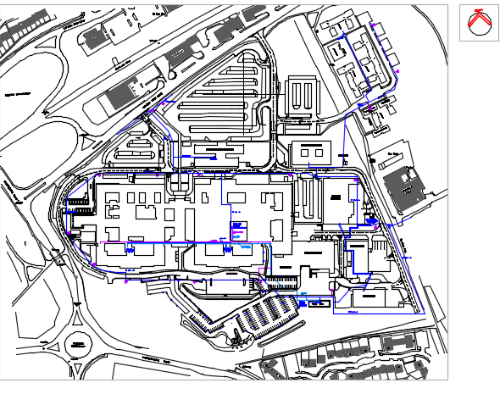

Appendix 2 – Schematic Drawing St John’s Hospital
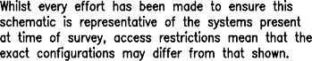
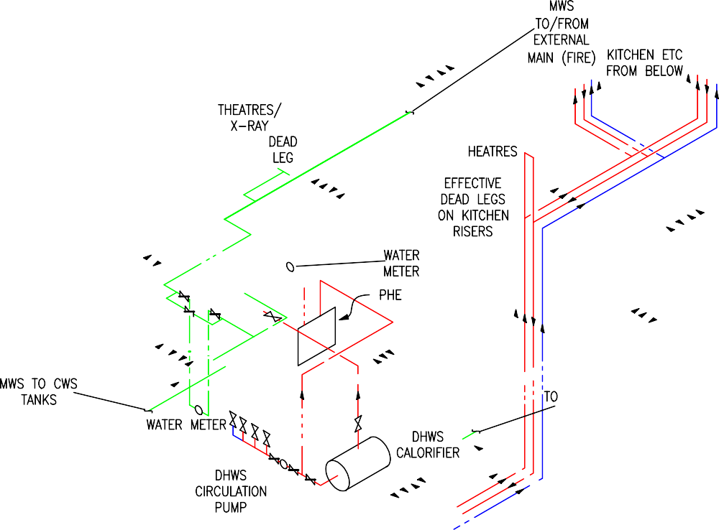

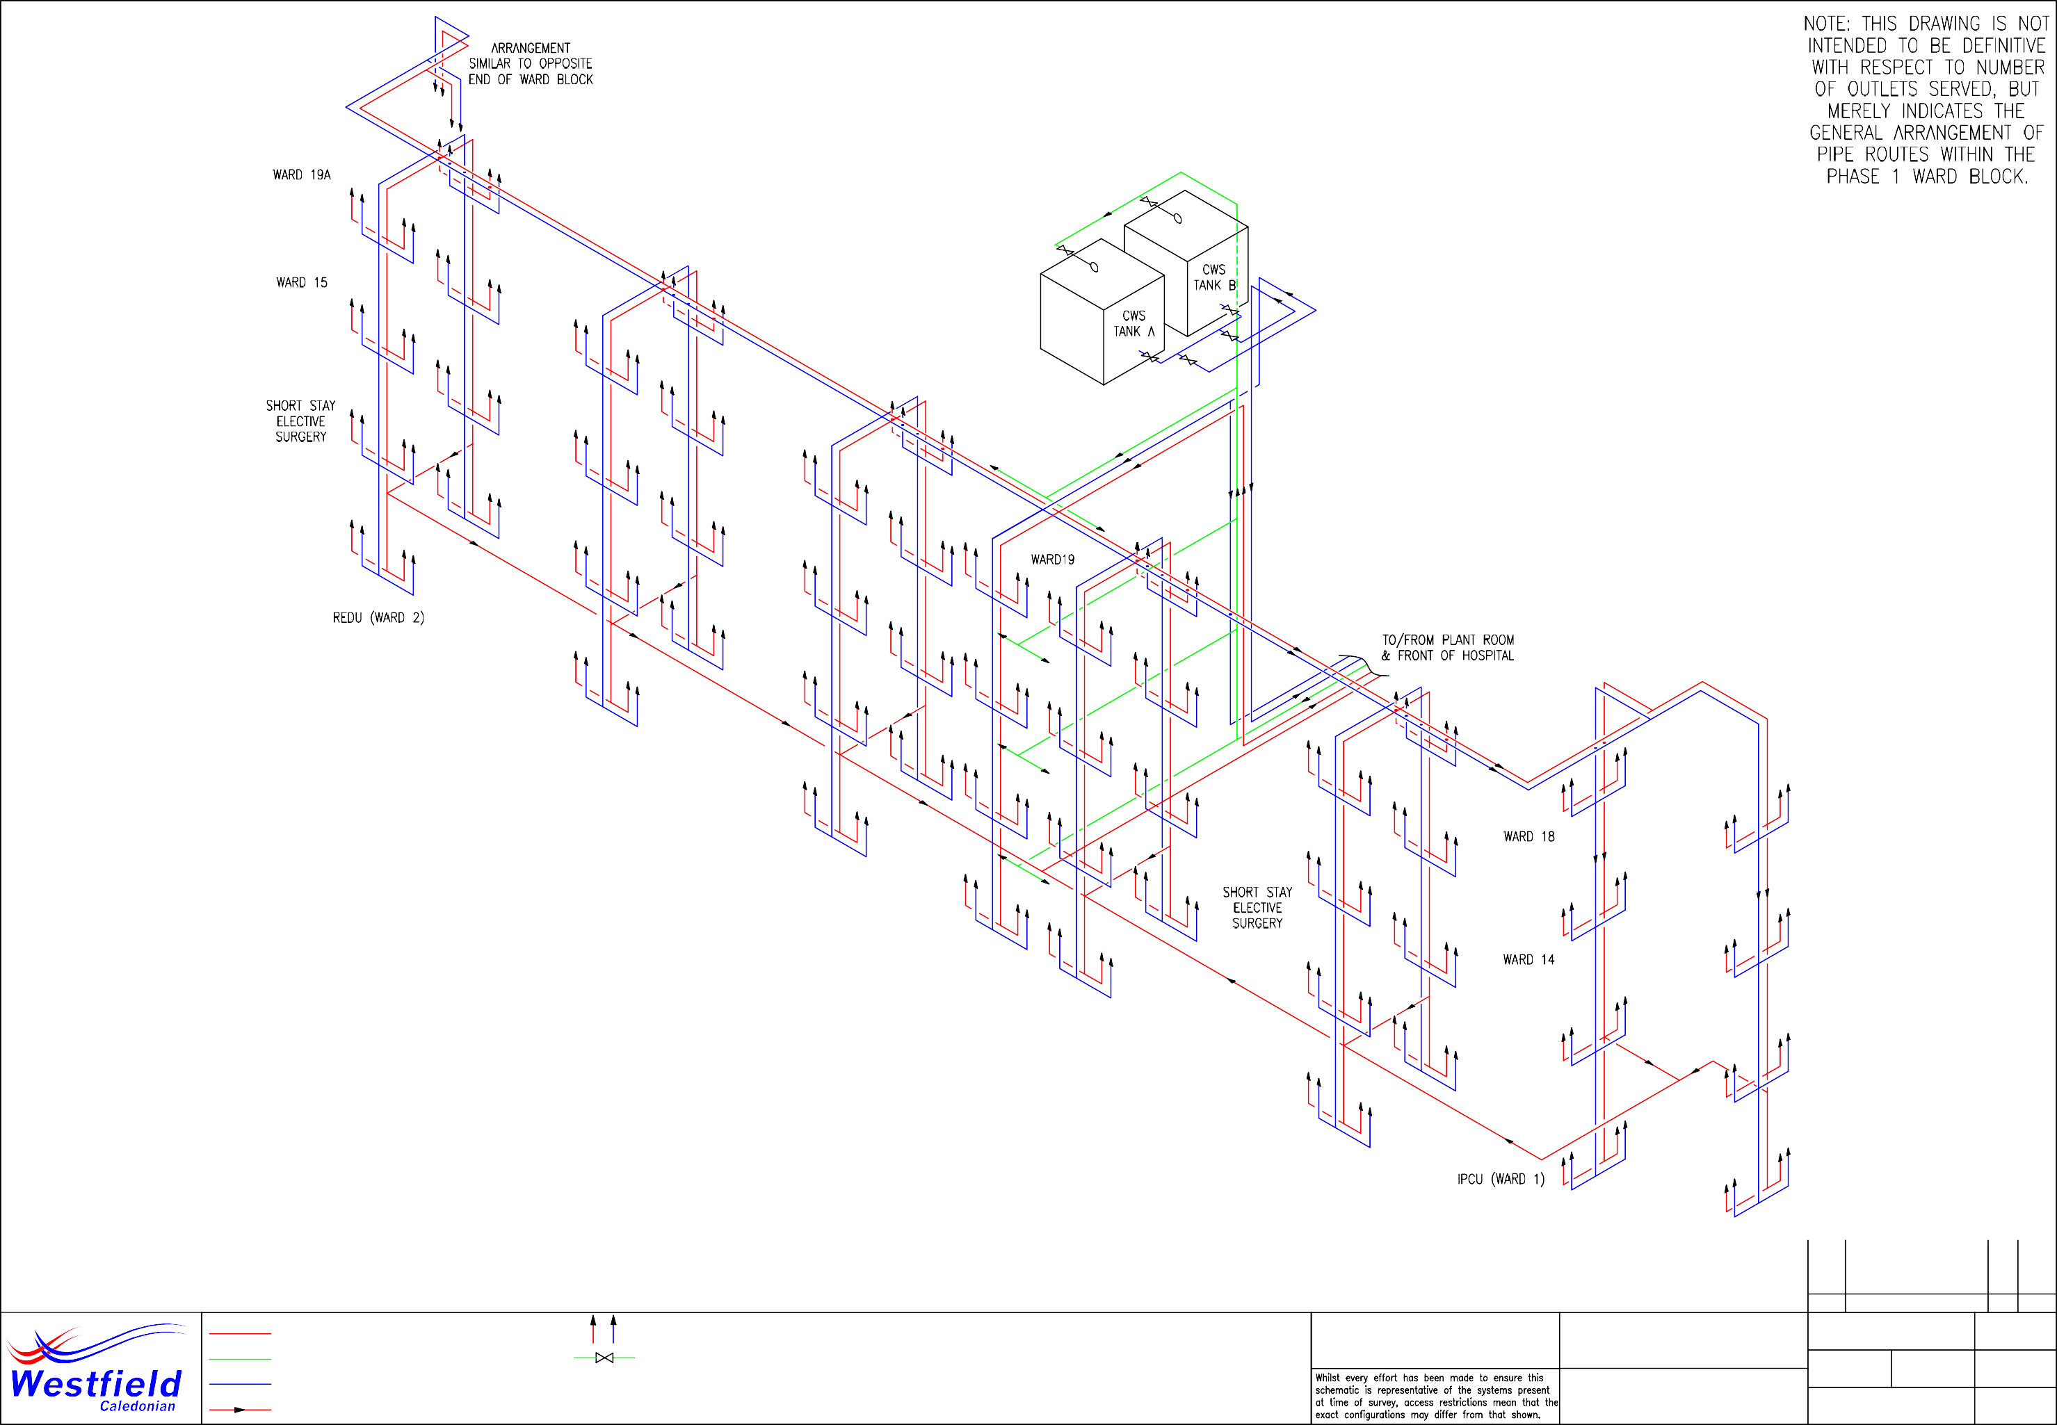

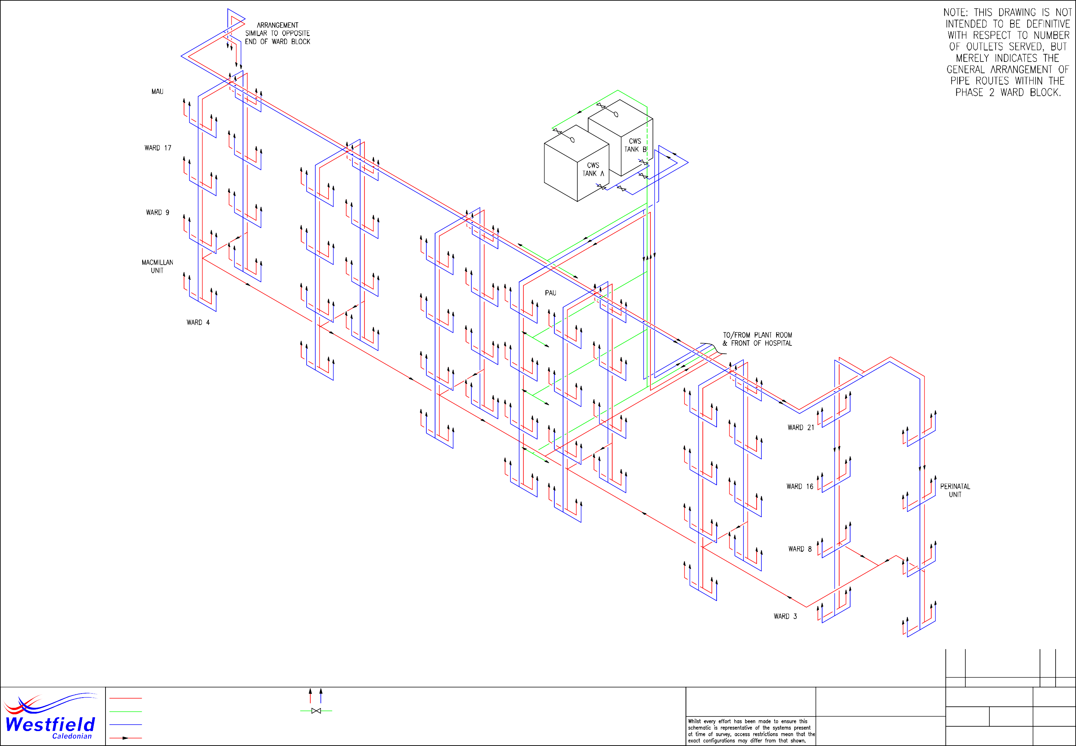

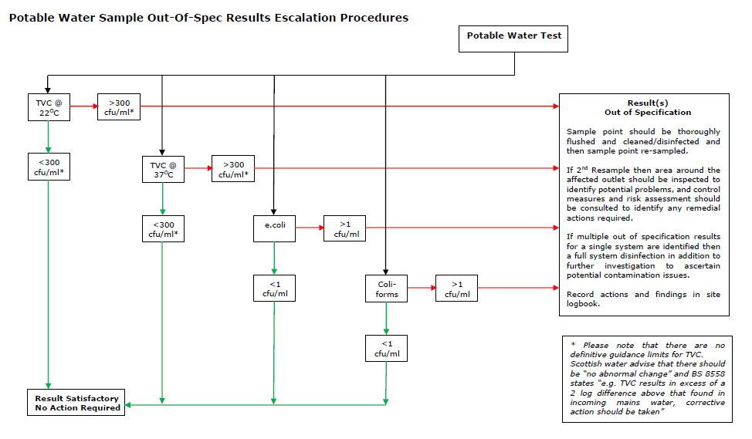
Appendix 3

Appendix 4 – Risk Assessment Review Guidance
Service | Remedial Action | When Added | Last Reviewed | Status | Comments
WSP | WSP to be derived and documented. | Nov-17 | October-2020 | Complete | See Water Safety Plan Review Section
 | Scald Risk Assessments required. | Nov-17 | October-2020 | Not Documented
Mains Water Service | Means of isolation and backflow protection to be verified at each point of entry. | Nov-17 | March-20 | Outstanding | To be confirmed.
 | The configuration of the supply arrangement to be verified. | Nov-17 | March-20 | Outstanding | To be confirmed.
 | All dead leg pipework to be removed as close to the branch points to prevent back-contamination. | Nov-17 | October-2020 | Outstanding | Schedule of dead legs to be compiled and programme for removal.
 | The need for the fire hose reel in the Phase I plant room to be investigated and removed if no longer required. | Nov-17 | October-2020 | Outstanding | The Fire hose reel remained fitted, at the time the survey was carried out
 | Dead leg created by valve by-pass at meter arrangement in Phase I to be removed. | Nov-17 | October-2020 | Outstanding

Service | Remedial Action | When Added | Last Reviewed | Status | Comments
Mains Water Service Cont’d | Add appropriate backflow prevention on MWS branch to closed systems in basement plant rooms. | March-20 | October-2020 | Outstanding
PHEs | Controls to be calibrated to ensure an accurate indication of temperature is provided. | Nov-17 | March-20 | Complete | The controls indicated a similar temperature to that recorded on the contact probe
 | Install additional gauges on flow and return pipes in plant areas to assist temperature monitoring. | Nov-17 | March-20 | Complete | BMS thermostatic sensors were noted on the flow and return pipe work allowing the flow and return temperatures to be monitored by the BMS.
CWS Tanks | Consideration to be given to cleaning and  Disinfecting the on-line tanks to prevent water quality deterioration. | Nov-17 | March-20 | Complete | The butterfly valves fitted to the tanks have been replaced. Two of the four tanks have also been replaced.
 | Alternatively, existing tanks to be replaced with vessels complying with current Water Byelaws. | Nov-17 | March-20 | Complete | Two of the four tanks have been replaced, works scheduled to replace the remaining two
 | Implement weekly standby tank flushing, to address dead legs created on down service and MWS supply pipe work, and new tank drain lines. | March-20 | October-2020 | Not confirmed
 | Consider installing an additional hatch on each tank remote from the MWS inlet to allow inspection and testing | October-2020 | October-2020 | New

Service | Remedial Action | When Added | Last Reviewed | Status | Comments
Accumulator Vessels | Fit drain to Renal Unit and main kitchen pressure set expansion vessels to facilitate weekly flushing. | Nov-17 | October-2020 | Outstanding | No drains installed to facilitate vessel flushing.
Pressurisation Equipment | Install double check valves on MWS supply connections to prevent back-flow. | Nov-17 | October-2020 | Outstanding | No double check valve was noted during the survey visit
Chilled Water Dispensers | Where elevated temperatures have been recorded, the chilling units should be repaired/replaced. | Nov-17 | October-2020 | Outstanding | A Schedule of chilled water dispensers should be drafted to determine which units require repair or replacement

Appendix 4

Risk Assessments
All relevant Westfield Caledonian risk assessments produced and approved for Water Systems related tasks are stored on the St John’s Hospital Shared Drive within the folder path “Water Quality>St John’s Hospital.

