Mail Count Form

PLEASE FILL OUT THE DETAILS AND TABLE BELOW WITH THE ITEMS YOU WISH TO BE PROCESSED AS OUTGOING MAIL:
Department
Site
Cost Centre
Date

Service Use Only
Product Description | Quantity | Logistics Use
Letter – 2nd class
Large Letter
Small Parcel
Medium Parcel
Special Requirements (special delivery, recorded, guaranteed delivery etc)
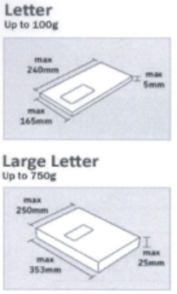
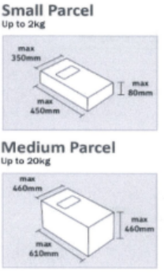
Department Sign Off (PRINT):
……………………………………………………
Department Sign Off (SIGNATURE):
……………………………………………………

Porter Sign Off:
…………………………………………………

